Spring Framework

Framework: It allows you to create the complex applications in a simple way, because it takes care of all the common features every application needs so that developers can concentrate on the new functionalities of the project, Framework forces developers to implement the application that is easy to test & maintain, some of the common features the framework provides are:-

1. Exception handling
2. Type conversion
3. Design patterns - related to object creation, initializing the object
4. Internationalization - adapting the applications to specific region or the language
5. Structuring the application - Configurations, Coding, testing and so on

Spring Framework: It is an application framework which can be used to develop any kind of applications like desktop, mobile, web, enterprise, cloud based

It has provided many modules for different types of applications, each modules are independent from other modules so that you can use the ones you need

ex: If you want to connect to the database you can use spring-jdbc module, spring-orm module, spring-data module and so on.

Some of the important modules are:

1. Spring Core: Provides all the basic features or necessities for the application - design patterns, type conversion, exception handling, object creation & initialization, internationalization
2. Spring MVC: For web application & rest based applications
3. Spring Boot: To easily setup the spring related features
4. Spring Cloud: For cloud based applications like microservices
5. Spring Security: Token based Authentication & Authorization (OAuth2.0)
6. Spring AOP: For Cross Cutting Concerns

Spring Core: It is one of the core module in spring that takes care of creating & maintaining the object using Dependency Injection feature, apart from that it provides many design patterns to easily develop the application

Dependency Injection: It is a design pattern where object is supplied to another dependent object ex: Service object supplying to controller, dao object supplying to service, transaction object supplying to service and so on.

Spring IoC: IoC stands for Inversion of Control, it is a container that maintains the objects, since the process of object creation and initializing is reverse it is called as Inversion of Control

Note: Dependency Injection is another way of initializing the object i.e., framework takes care of initializing the object or initializing the dependencies

There are 2 types of dependency injection

1. Setter Injection: Framework supplies the dependencies through setter methods
2. Constructor Injection: Framework supplies the dependencies through Constructor arguments

Benefits of Dependency Injection

* Loosely coupled code
* Flexible to the changes in the implementation

Note: You must use interface based approach when you want to get the full advantage of dependency injection

Usual way of initializing the dependencies i.e., dao of Service that needs instance of EmployeeDao

1. EmployeeDao dao = new EmployeeJdbcImpl();
2. EmployeeDao dao = ObjectFactory.getDaoInstance();

Both the references are going to be initialized by the 2nd statement is loosely coupled compare to the first statement, in the 2nd statement if the implementation object needs to be changed then we only change the factory pattern class no the service layer code

Dependency Injection way of initializing the dependencies

1. EmployeeService(EmployeeDao dao) { this.dao = dao; }
2. setDao(EmployeeDao dao) { this.dao = dao; }

Both the code are called by Framework by supplying the instance of dao, here the framework creates the instance of EmployeeDao & EmployeeService & supplies the EmployeeDao instance to the EmployeeService

Both the statements are loosely coupled & flexible to the changes as you never create object of either EmployeeService or EmployeeDao because framework takes care of object creation.

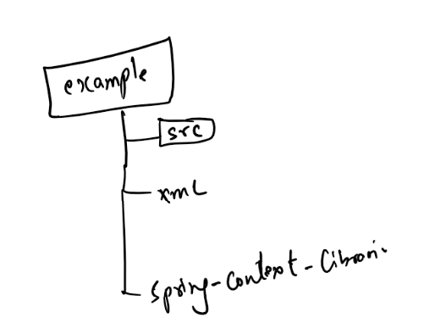

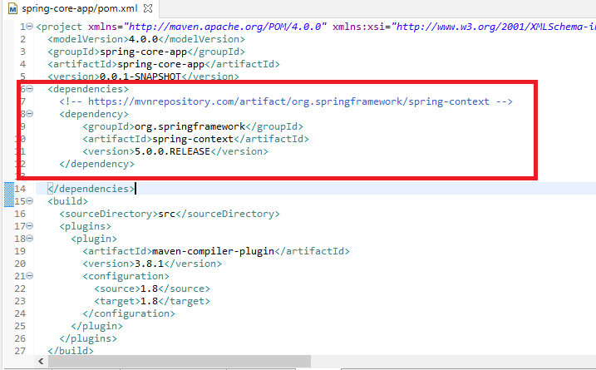

Setter Injection: Object initialization happens via setter method

Project Structure:

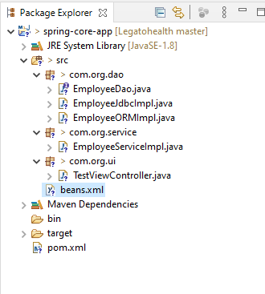

EmployeeDao.java

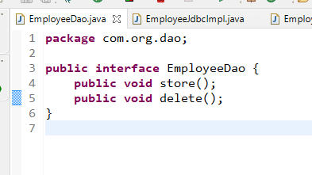

EmployeeJdbcImpl.java

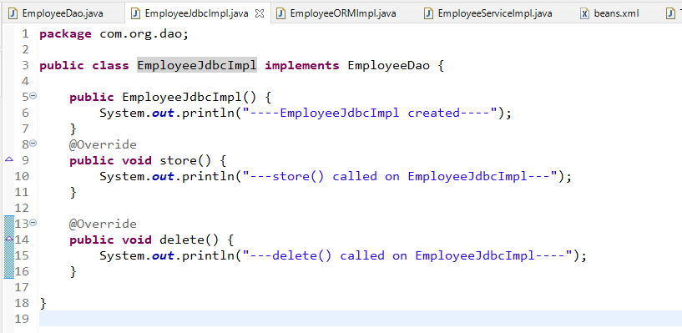

EmployeeORMImpl.java

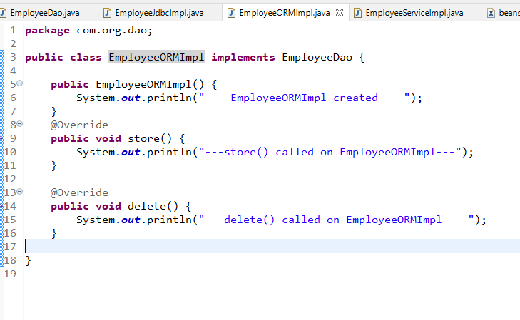

EmployeeServiceImpl.java

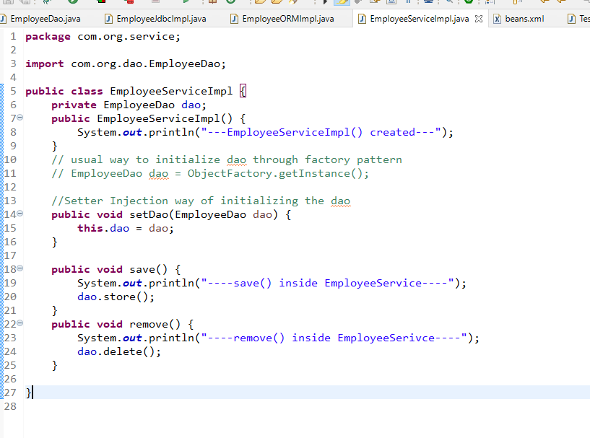

beans.xml

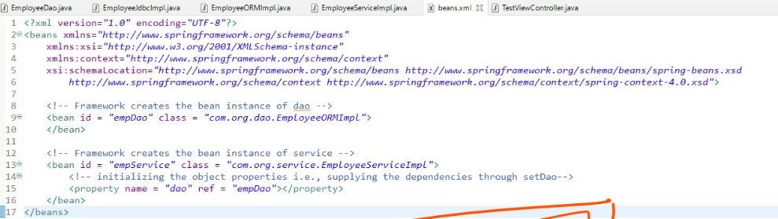

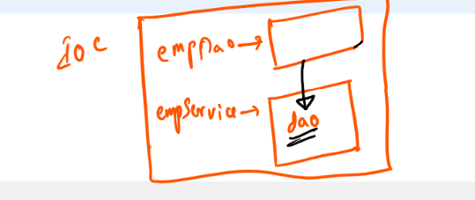

TestViewController.java

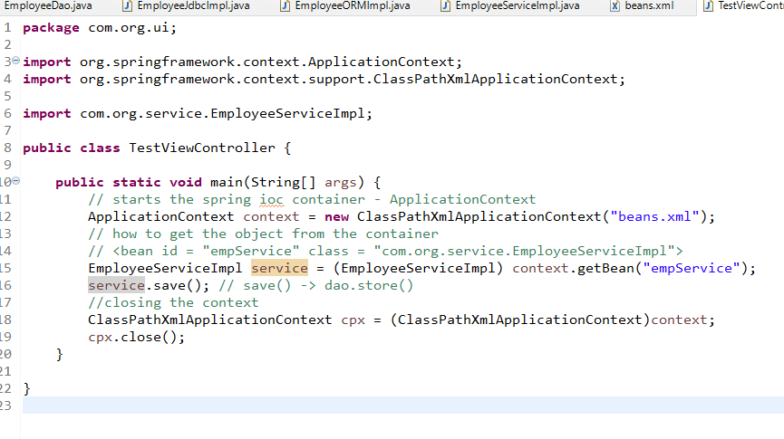

Output:

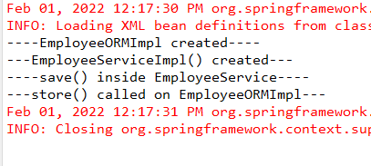

The above code is supplying the EmployeeDao implementation instance using setter injection i.e., it is calling setDao() method & passing the object that implements EmployeeDao, but another way of supplying the dependency is via constructor argument.

Constructor Injection: Object initialization happens via constructor argument

Sometimes you may have a class where the properties must be initialized only through constructors and after the object is created nobody needs to modify its property in that case you there wouldn’t be setter methods for that property, in such cases you can initialize only by constructors

Change the EmployeeServiceImpl.java

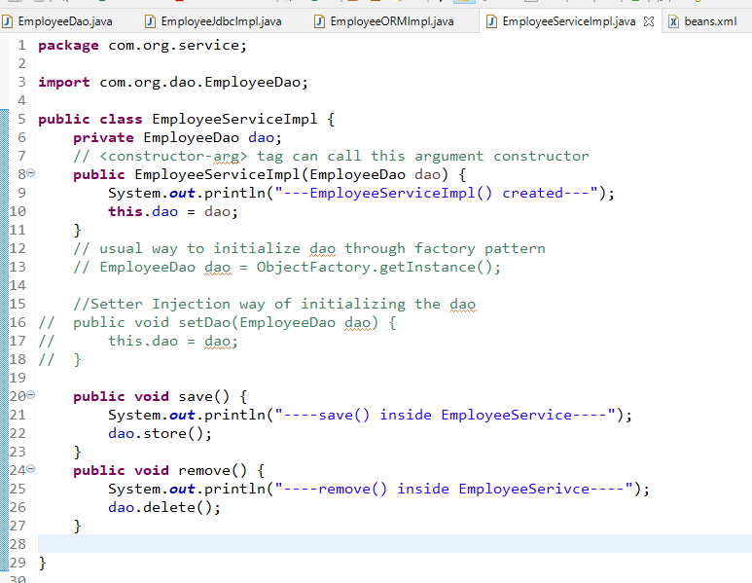

beans.xml

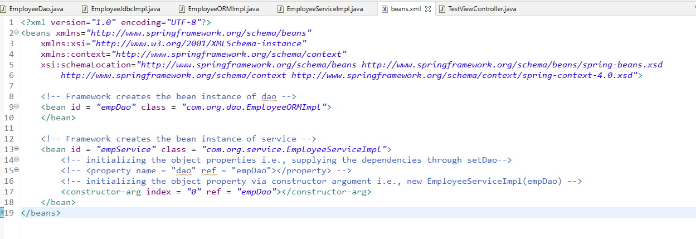

The above configuration supplies the dao to the service using argument constructor,

TestViewController.java

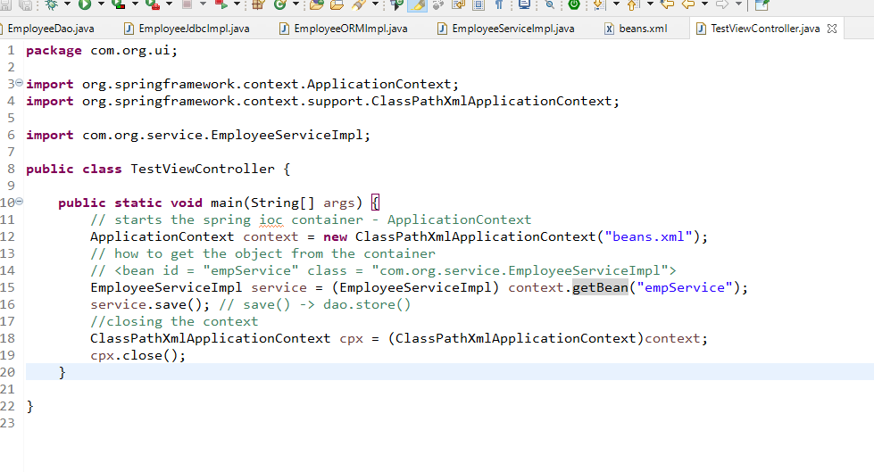

Scopes of bean

1. singleton: By default every bean is singleton per <bean> configuration
2. prototype: This allows multiple instance of the bean to be created per <bean> configuration.

<bean id = ‘xyz’ class = ‘com.org.Xyz’> : Xyz is single ton

<bean id = ‘abc’ class = ‘com.org.Abc’ scope = ‘prototype’>: Abc can have multiple instances

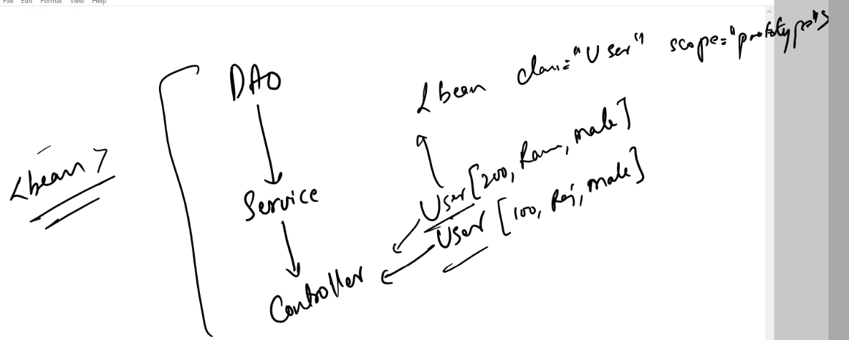

Note: If you omit scope attribute in the <bean> tag then they are considered singleton.

Java based configuration:

Here you can configure the beans through annotations, spring has provided some annotations that are scanned to configure the classes, since most of the applications uses layered architecture spring has introduced annotations that can be used for the classes that are part of particular layer, like model, controller & service layers.

Some of the annotations are:

@Component

@Service

@Repository

@Controller

@RestController

@Configuration

@Bean

@Autowired

@Qualifier

Annotations like @Component, @Service, @Controller, @Repository, @RestController, @Configuration creates instance in the IOC, i.e., similar to <bean>

@Component: It is to instantiate the normal java class like Utility classes, instead of configuring in the xml like <bean> tag for the class you can use @Component

@Controller: It is to instantiate the class that acts like controller

@Service & @Repository: These are specific to service & dao layers, both the annotations instantiates the class

@RestController: This is to instantiate the class used for REST services.

@Autowired: This injects the object to the dependency, it automatically checks the type of the objects & initializes the object

@Service  
class Abc { }

@Controller  
class Xyz {  
 @Autowired  
 Abc a;  
}

Here both Abc & Xyz instances will be created in the container, & Abc object is assigned to the Xyz.a property because @Autowired.

The advantage is you don’t have to write <bean> in the XML now onwards.

The configuration you keep in the XML is to scan all these classes belonging to some packages.

*<component-scan base-package = ‘com’>*

The above tag scans all the classes inside com folder & their sub-folders, then instantiates those classes accordingly based on the annotations like @Component, @Service, @Repository.

beans.xml

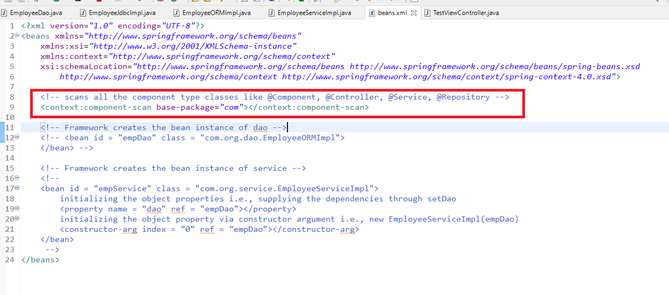

Add @Repository to EmployeeJdbcImpl.java

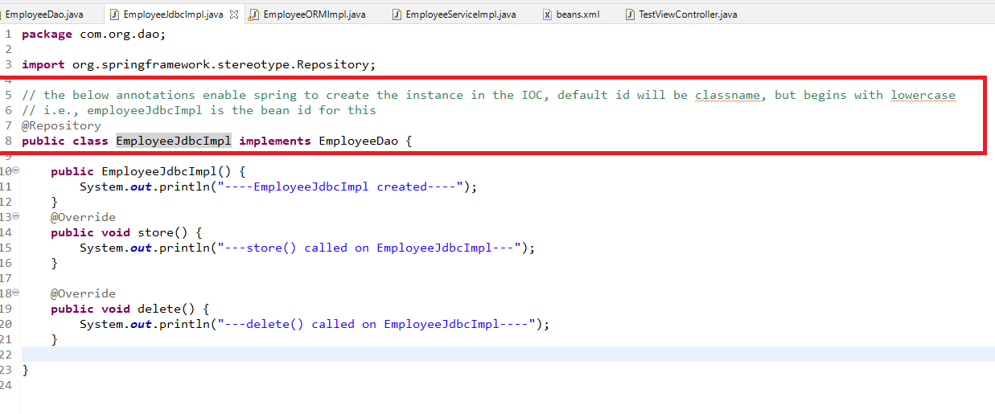

Using @Service in the EmployeeServiceImpl

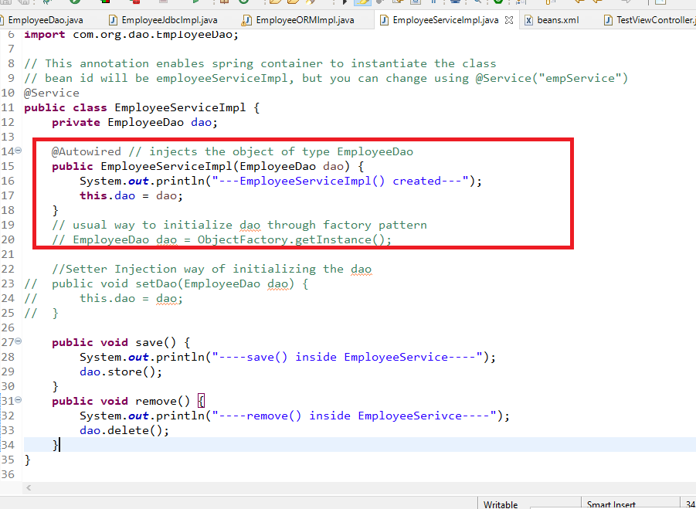

@Autwired injects the object based on the type, it can be used on top of the constructor, setter method or on the variable

TestViewController.java

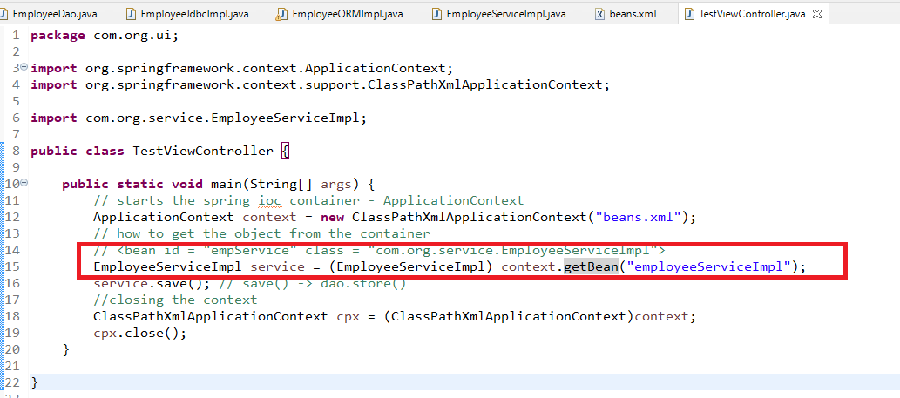

Output:

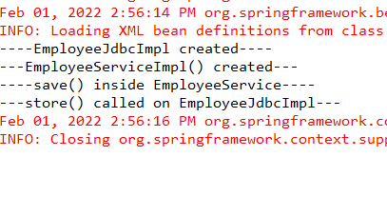

The above code works fine as long as there is only one instance of EmployeDao, but if there are more than one instance of EmployeeDao i.e., both EmployeeJdbcImpl and EmployeeORMImpl then you will get exception, because framework looks to supply the object of EmployeeDao but it doesn’t know which object to supply as there are two objects, if it was only one type, then there wouldn’t by any exception.

To solve this you can use @Qualifier(name = ‘beanName’)

EmployeeORMImpl.java

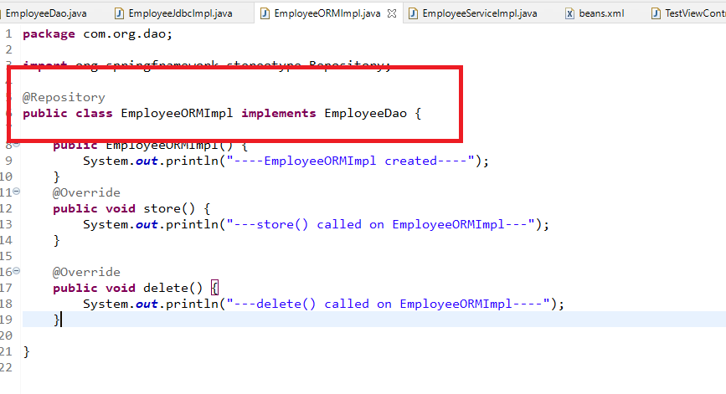

The @Repository is instantiating EmployeDao type, but we have another class of EmployeeDao which is also created in the IOC

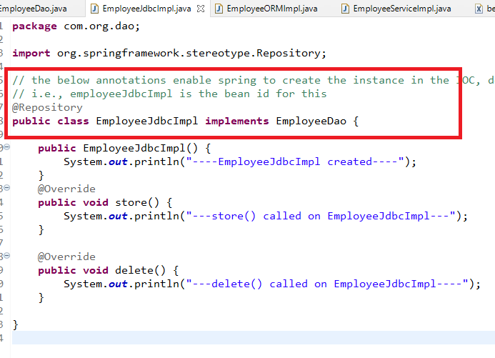

Note: Since both the classes fall into EmployeeDao type, then @Autwored on EmployeeDao will give error

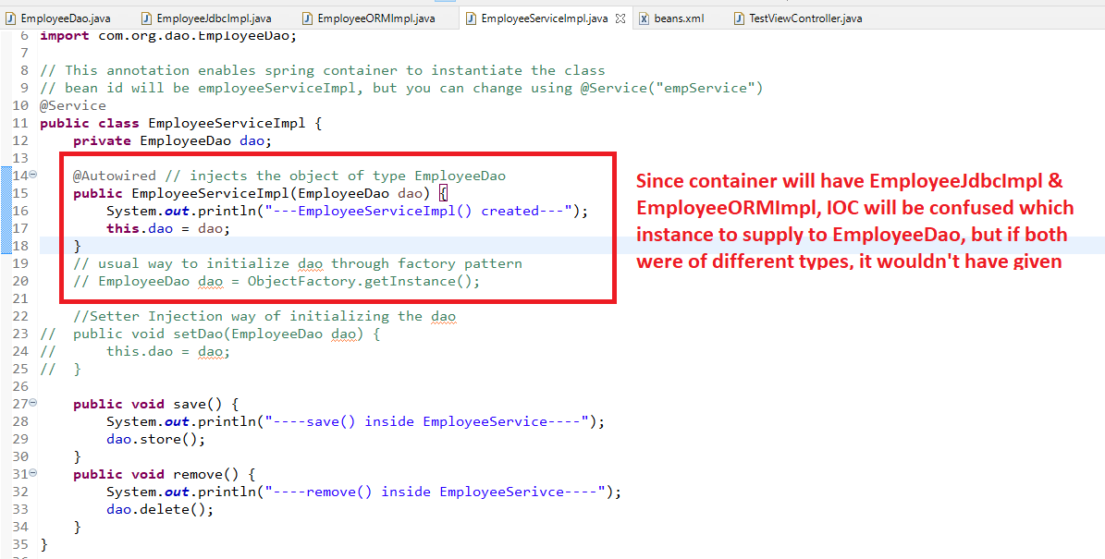

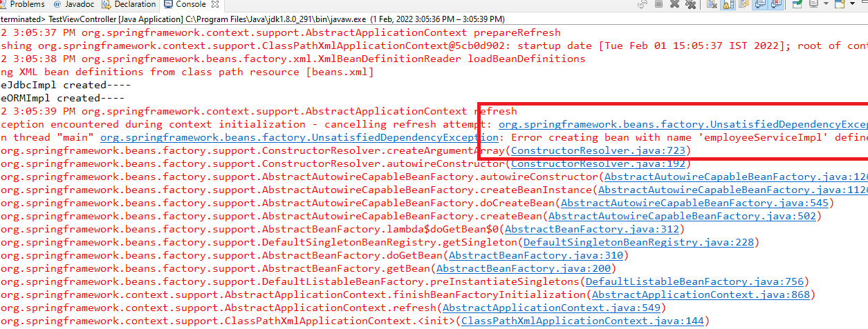

To avoid this you can use @Qualifier on EmployeeServiceImpl or @Primary on the implementation class.

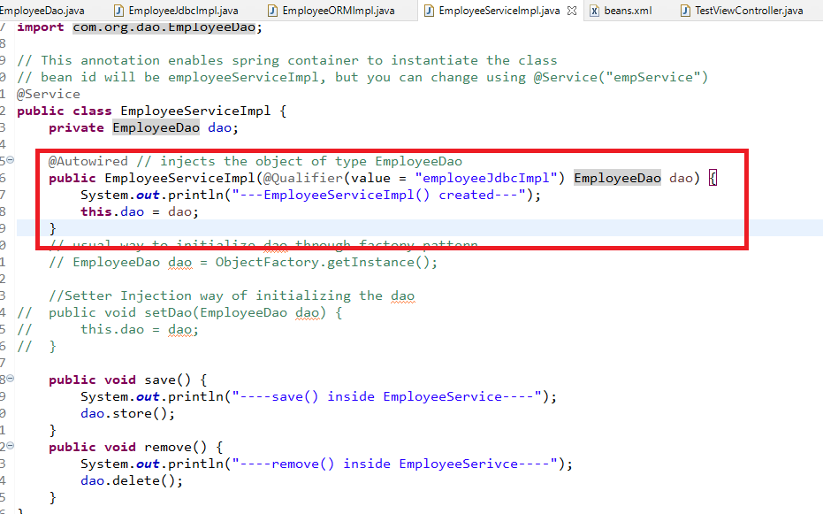

Output:

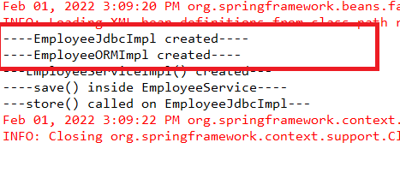

Though the IOC creates EmployeeJdbcImpl & EmployeeORMImpl, it injects EmployeeJdbcImpl to the EmployeeService.dao because of @Qualifier.

Another way to solve this is without using @Qualifier i.e., using @Primary on top the class to give preference to it when there are multiple candidates of same type

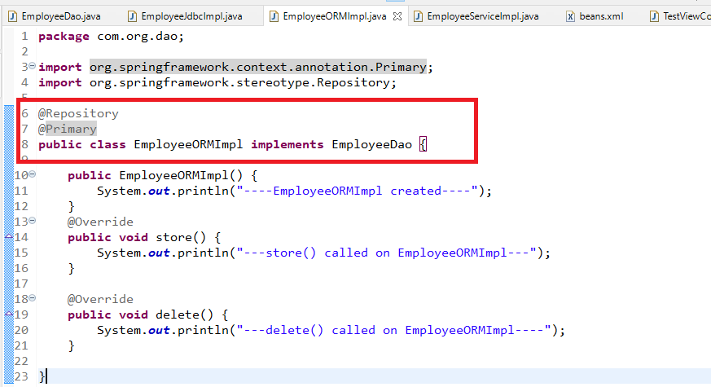

Note: If you use @Qualifer in the EmployeeServiceImpl, then it override @Primary, preference will be given to @Qualifer in that case.

Spring AOP

AOP stands for Aspect Oriented Programming, it is used to add cross cutting concerns i.e., logics that are not part of business requirements without actually writing in the business logics, you can execute these concerns without mentioning it in the business logics.

Suppose you want to execute some logics before executing the actual business logic or after executing the actual business logics, then you can use AOP.

Terminologies

1. Aspect: The classes that will have cross cutting concerns which need to be executed when the actual business logics is executing
2. Join Point: This is the actual business logics
3. Advice: This is the cross cutting logics
4. Point Cut: These are the expressions written on the advice that mentions what join point to be considered while advice is executing

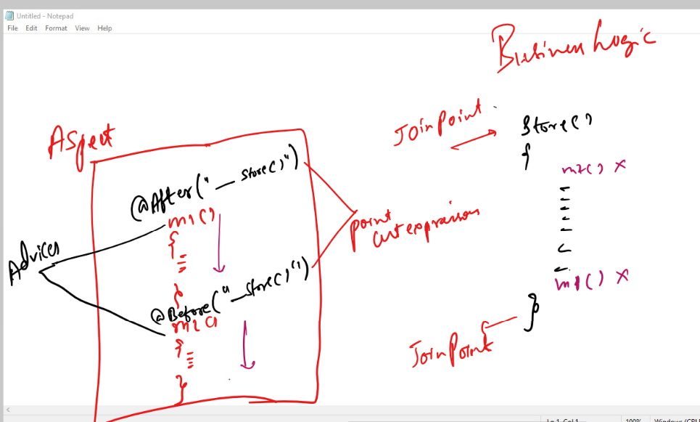

pom.xml

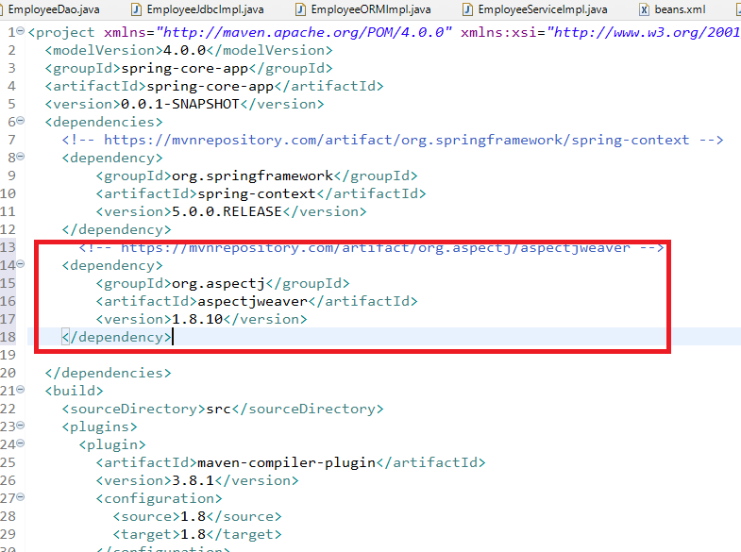

You need to use the aop namespace in the spring bean configuration file, so that you can use one proxy object, which is used to call the cross cutting concerns when the actual logics are executing.

beans.xml

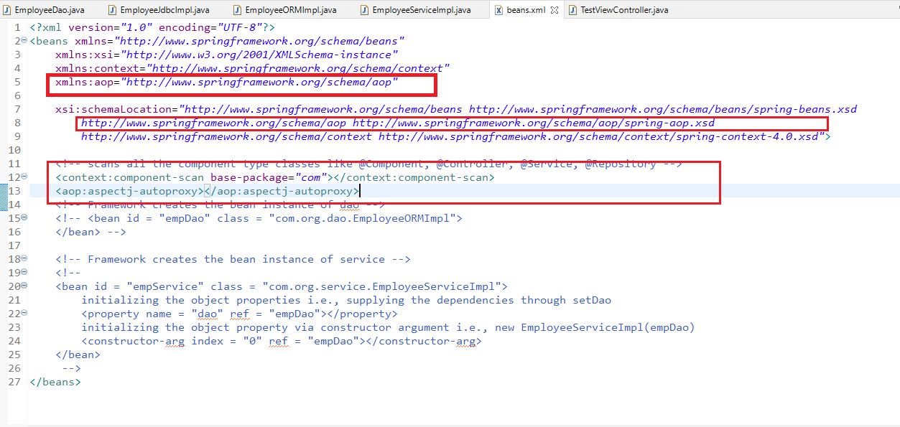

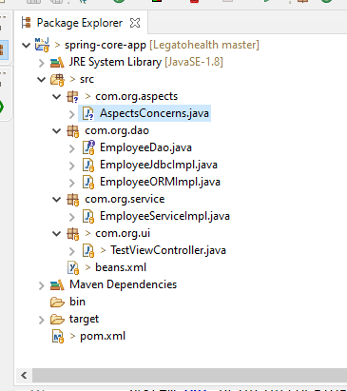

AspectConcerns.java

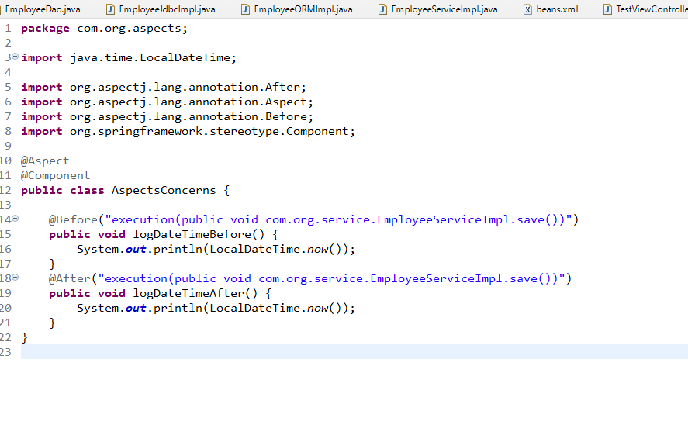

TestViewController.java

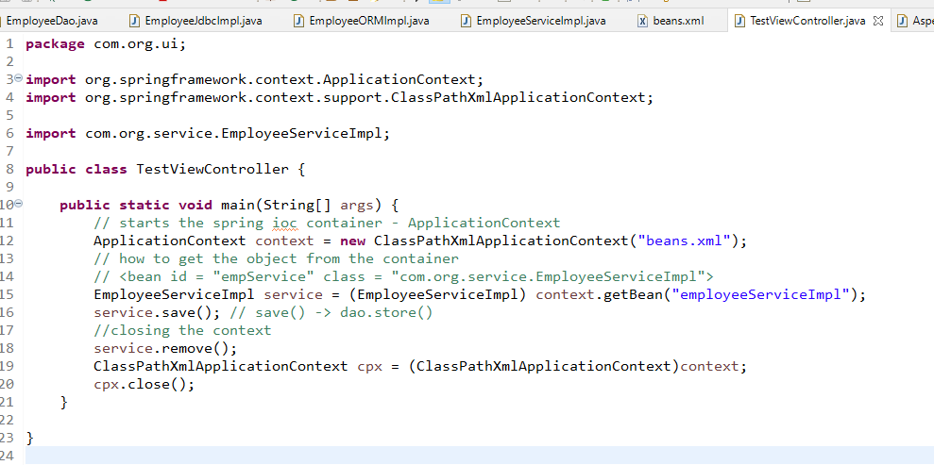

Note: No changes in any other files

Output:

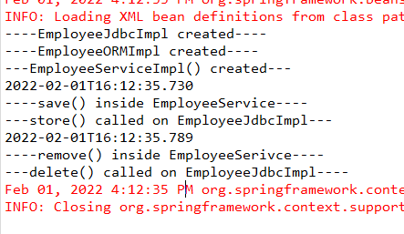

You can see the cross cutting concerns executing before save() begins & after save() completes, but its not executing for remove(), as the advice doesn’t have the expression for remove.

Note: For all the other modules of spring, spring context is the base i.e., dependency injection, setter, constructor injection, autowiring, configuration and so on.

Spring MVC

It is a module used to develop web applications using spring concepts, it uses controller to decide what is the next page to be rendered, it uses front-controller to route all the requests to appropriate controller.

DispatcherServlet: Spring MVC provides a front-controller called DispatcherServlet, it is an inbuilt class that takes all the incoming requests & routes the requests to the appropriate controller.

Every web application needs to be run on the server & every such application will have one configuration file related to the project i.e., web.xml

web.xml: It is a main file that will have web application configurations like request routing, welcome page, global configurations and so on.

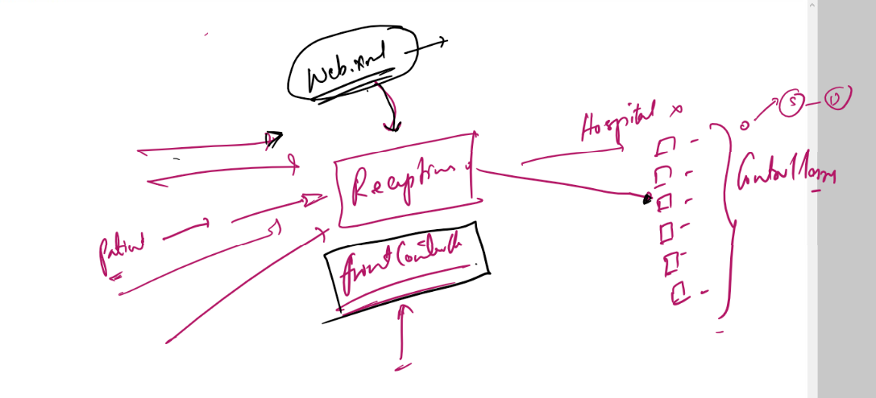

Project Structure

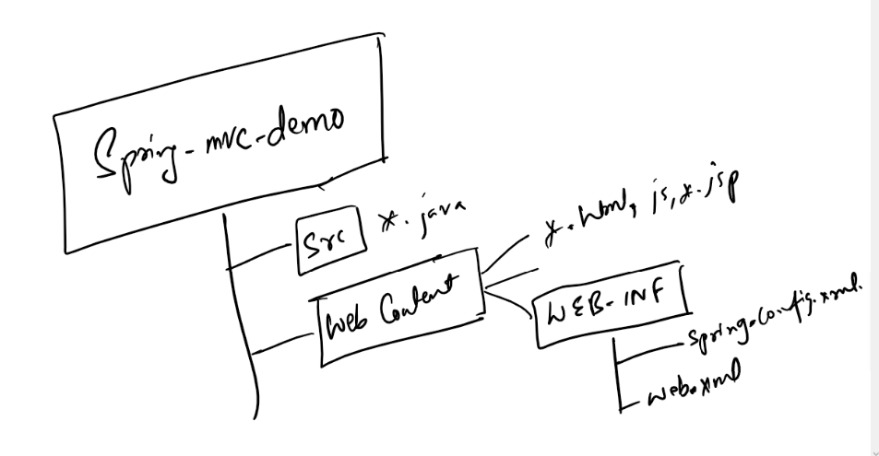

The spring-config.xml: it is the bean configuration file where you can have all the spring related configurations like component-scan, <bean> configurations, data source configurations.

Front Controller:

This handles all the requests coming to the application & initializes the spring container it has an inbuilt code to initialize the spring container i.e.,

ApplicationContext ctx = new ClassPathXmlApplicationContext(xml-file-name);

The spring container would maintain all the instances that are configured in the xml file & also with component scan.

We need to create Dynamic Web Project

* Dynamic Web Projects is run on server, it will not have main method, it will have html, css, js, jsp, java files, xml files and etc.

Configuring the server

* Ensure that you are in Java EE perspective
* In Server tab you will get a server link
* Select the server
* Start & stop the server

Create the Dynamic Web project & select web.xml, the project structure looks as below

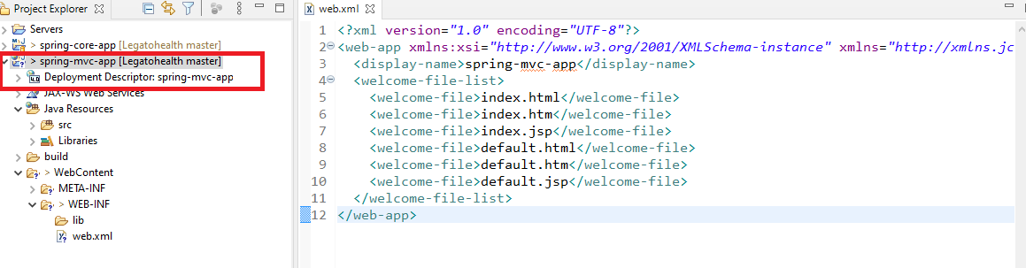

Here the project should be configured to have spring configuration file and also web.xml must have Front Controller configuration.

Create index.html in WebContent as it is mentioned in the welcome file list

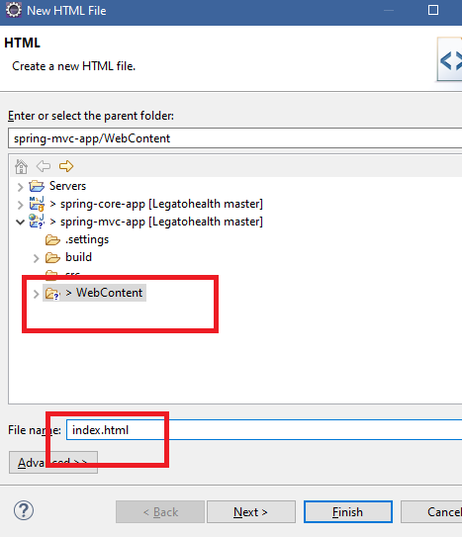

Note: index.html is case sensitive for the server, if you create Index.html with ‘I’ in uppercase it doesn’t work

index.html

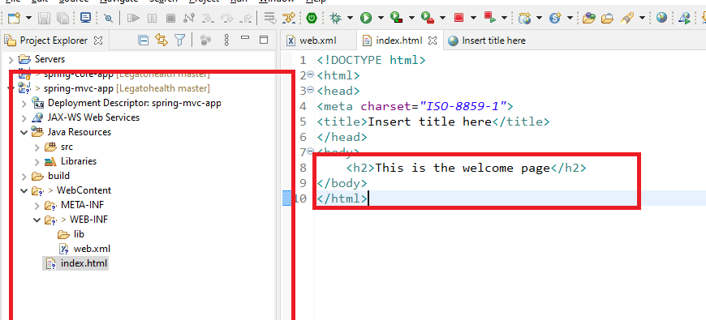

Convert the project to maven project so that you can add spring libraries

1. spring-webmvc
2. spring-context(automatically selected when you choose any spring module)

pom.xml

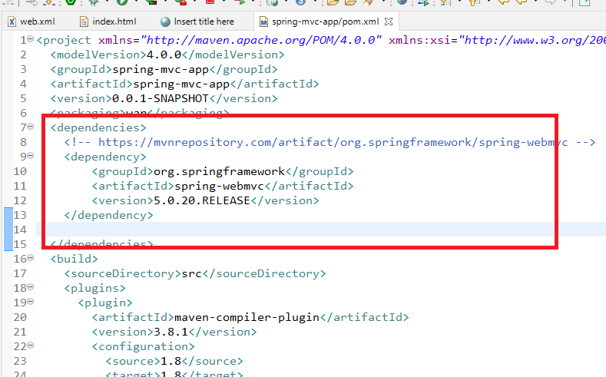

Note: Since we are using spring framework to develop web applications, we need to create controllers, services, repositories hence we need a configuration file for spring, before that we need to configure front controller in web.xml

web.xml

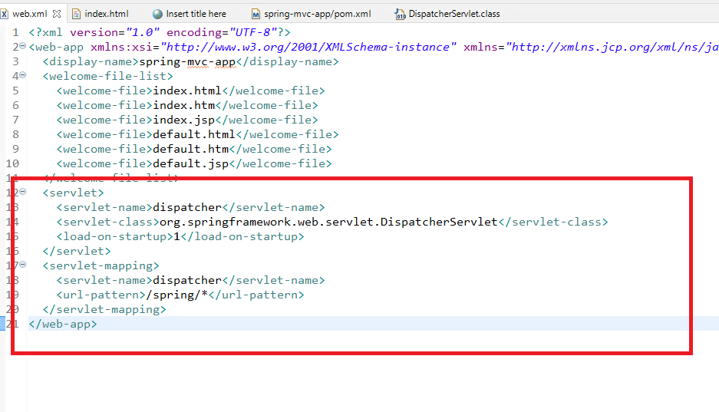

The Task of DisatpcherServlet i.e., FrontController is

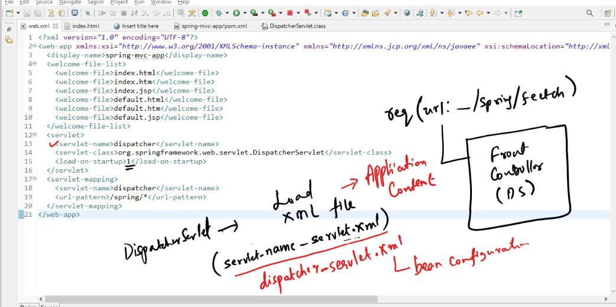

1. looks for a spring configuration file that matches to the <servlet-name>-servlet.xml, means dispatcher-servlet.xml
2. It looks for the xml file inside WebContent/WEB-INF/
3. Loads that xml file and initializes the spring container with all the beans mentioned in that xml file (dispatcher-servlet.xml)
4. It will have container ready so that you can use all the spring features like @Autowired, @Component, @Service, @Repository, @Controller, @RestController and so on.

dispatcher-servlet.xml

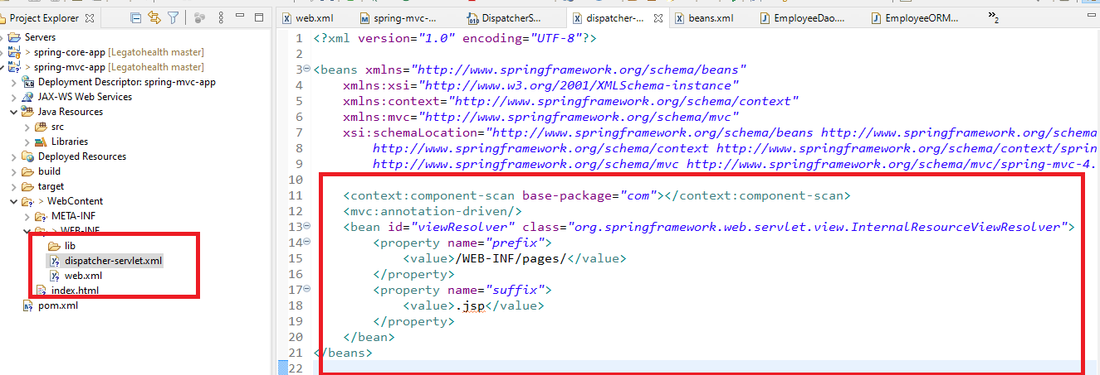

Note: dispatcher-servlet.xml file name must match to the <servlet-name> of web.xml, it is loaded by Front Controller i.e., DispatcherServlet

1. component-scan: scans all the annotated classes of com & their sub packages, registers all the beans in the container
2. view resolver would locate the jsp files in the WEB-INF/pages/ folder, if the controller renders the jsp page name, the view resolver searches jsp page inside WEB-INF/pages
3. You can keep jsp’s inside WebContent also, then you don’t need view resolver

Now you can create a controller to handle the request and navigate the jsp to the user

UserController.java

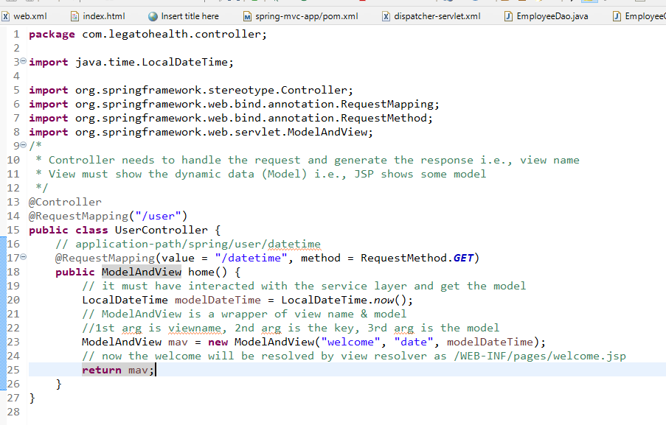

WEB-INF/pages/welcome.jsp

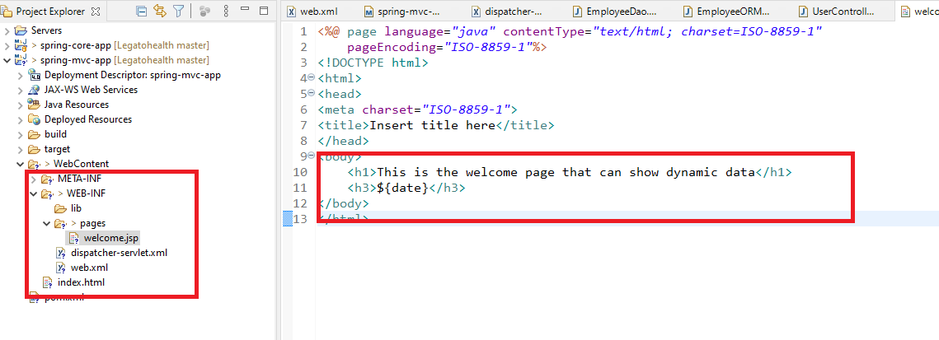

${date}: it is the key that holds the model, which is mentioned in ModelAndView 2nd argument.

You need to send request to the /spring/user/datetime, hence in index.html you can create a link to this URL using <a>

index.html

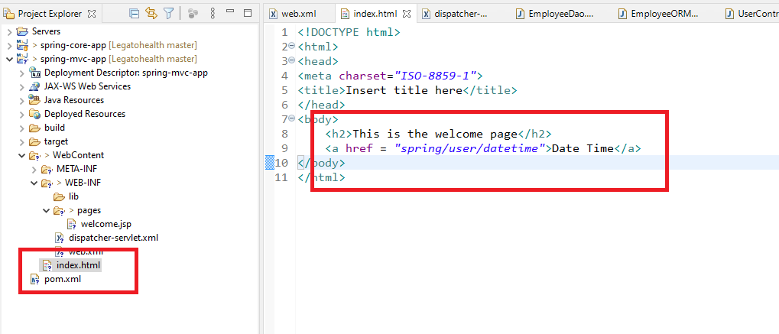

Output:

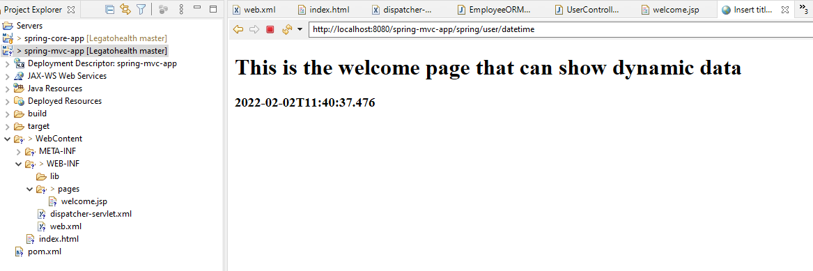

Flow of the above code

